You are a legal assistant tasked with summarizing a deposition transcript. Your goal is to produce a structured summary that includes:

- Page and line references for each key testimony
- A clear topic label for each section (e.g., Product Design, Safety Testing, Damages)
- A concise summary of the testimony

Format the output as a table with the following columns:
| Page/Line | Witness | Topic | Summary |

Instructions:
1. Identify all substantive testimony relevant to the case.
2. Group testimony by topic and maintain chronological order.
3. Use neutral, objective language—do not interpret or speculate.
4. Include direct quotes only when legally significant.
5. Avoid summarizing procedural or off-record discussions.

Transcript Input:
[Insert full or partial deposition transcript here]

Output:
[AI-generated summary in table format]

🛠️ Optional Customizations
You can tweak the prompt depending on your needs:
- For topic-specific summaries:
“Focus only on testimony related to [e.g., breach of contract] and exclude unrelated content.”
- For multi-witness depositions:
“Include the witness name in each row and separate summaries by witness.”
- For compression ratios (e.g., 5:1):
“Summarize at a 5:1 ratio—one summary entry per five transcript pages.”
- For export-ready formats:
“Format the output for easy copy-paste into Excel or Word.”

Absolutely, Toya! Here's a sample deposition summary using the reusable template we built earlier. This example assumes a deposition in a product liability case involving a defective kitchen appliance. The witness is a former product engineer.
🧾 Deposition Summary – Sample Format
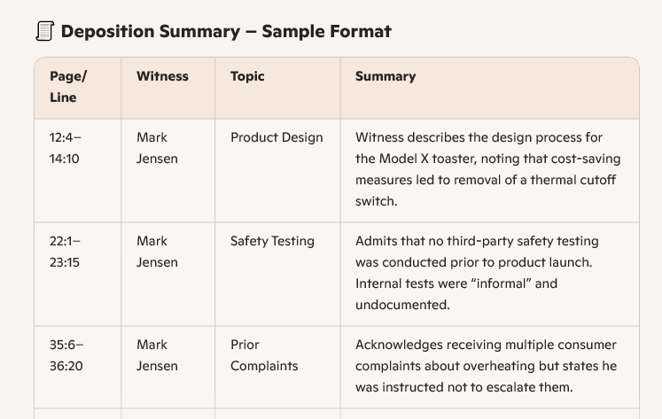
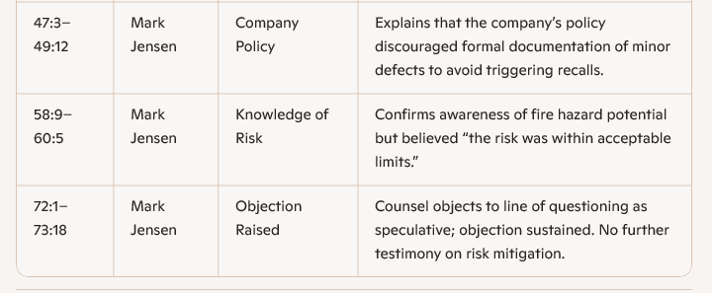
This format keeps things clean, legally relevant, and easy to scan—perfect for trial prep, motion drafting, or internal review. If you’d like, I can tailor this to a different type of case (employment, medical malpractice, etc.) or generate a longer mock summary. Just say the word.
Deposition Summary – Dr. Emily Rhodes (Medical Malpractice Case)
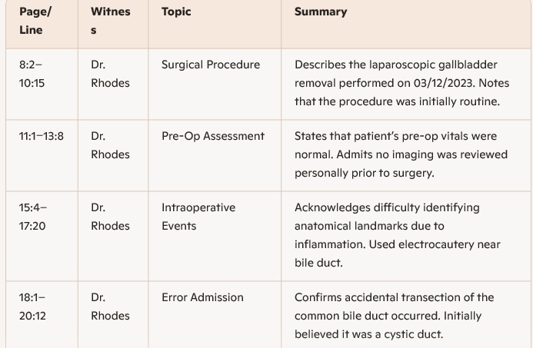
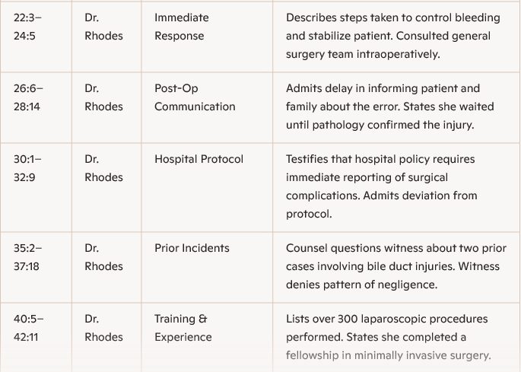
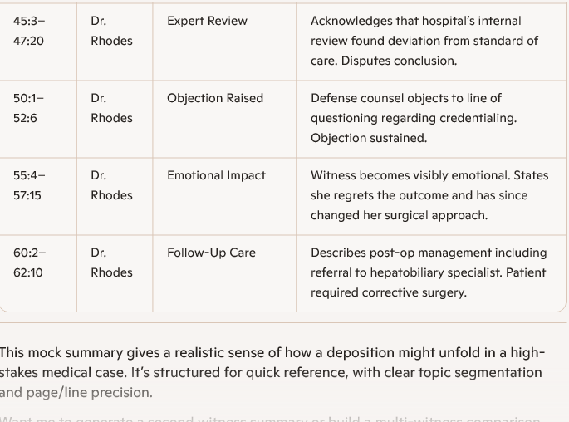

Please provide a list of prompts for an AI model that could be used to construct a legal deposition transcript summary with page/line designations and topic columns

Absolutely, Toya. If you're building or using an AI model to generate legal deposition summaries with page/line references and topic columns, you'll want prompts that are precise, structured, and legally aware. Here's a curated list of prompt ideas tailored for that purpose:
Core Prompts for Deposition Summary Generation
These prompts guide the AI to extract key testimony and organize it by page/line and topic:
- "Summarize this deposition transcript by identifying key testimony with page and line references. Organize the output into columns: Page/Line, Topic, Summary."
- "Create a 5:1 page-line summary of this deposition. Include columns for Page/Line, Witness Name, Topic, and Key Points."
- "Extract all testimony related to [specific topic, e.g., 'contract breach'] from this transcript. Include page/line citations and summarize each relevant section."
- "Generate a deposition summary with hyperlinks to transcript page/line numbers. Include columns for Topic, Summary, and Source Reference."
- "Identify and summarize objections raised during the deposition. Include page/line, type of objection, and context."
Topic-Focused Prompts
These help the AI isolate specific legal issues or themes:
- "List all instances where the witness discusses [e.g., 'product liability'] with page/line references and a brief summary."
- "Create a summary of testimony related to damages. Include page/line, topic (e.g., economic vs. non-economic), and summary."
- "Extract and summarize all expert witness opinions. Include credentials, page/line, and topic discussed."

Formatting & Output Prompts
These prompts ensure the AI structures the output in a usable format:
- "Format the deposition summary in a table with columns: Page/Line, Topic, Summary, and Witness."
- "Generate a summary in Word-compatible format with headings for each topic and embedded page/line references."
- "Create a deposition summary with a timeline of events discussed, including page/line citations and topic tags."

Advanced Workflow Prompts
For integrating into legaltech workflows or APIs:
- "Generate a JSON output of the deposition summary with fields: page, line, topic, summary, and witness name."
- "Tag each summary entry with metadata: relevance score, legal issue category, and cross-reference ID."
- "Summarize multiple deposition transcripts into a unified summary with page/line references and topic columns for each witness."

